CPUC Staff Reply Comments on CAISO’s Business Practice Manual (BPM) Change PRR-1280
Submitted by | Company | Date Submitted
Michele Kito  michele.kito@cpuc.ca.gov  415-703-2197 | Energy Division, CPUC | October 20, 2020

- Summary
CPUC Energy Division staff continues to oppose CAISO’s proposed changes to its Business Practice Manual (BPM) which would, in effect, no longer count the investor owned utility (IOU) demand response that the CPUC allocates to load-serving entities. In its initial comments, the CPUC stated the following:
To effectuate this, CAISO proposes to no longer accept the “credits” the CPUC uses to reduce system resource adequacy requirements for these Demand Response resources. With this addition to its BPM, CAISO upends the CPUC long-standing practice, which allows CPUC- jurisdictional entities to use Demand Response to meet their system resource adequacy (RA) obligations. As discussed further below, CPUC staff believe that the proposed change intrudes upon CPUC jurisdiction, is procedurally improper, is inconsistent with Board approval, and inconsistent with state law and state policy regarding the treatment of Demand Response resources.
On October 6, 2020 CAISO posted its responses to the issues raised by stakeholders, including PG&E, SDG&E, SCE and the CPUC and moved this BPM change to the recommendation phase, indicating that it planned to move forward with the proposal.
At a very broad level, CPUC staff understands and appreciates CAISO’s concern about the reliability of the grid, which we share as well. However, we believe that the IOU demand response programs that the CPUC allocates through credits to all jurisdictional entities (i.e., the base interruptible program and proxy demand responses) materially helped to address the reliability issues experienced during the August heatwave and rotating outages. Accordingly, we do not believe that it would be appropriate at this time for CAISO to reject the CPUC’s DR credits, to determine unilaterally that DR resources neither reduce nor meet RA requirements, and procure backstop capacity to replace these DR resources in full. Not only would this be an expensive proposition for ratepayers, but as noted previously, it does not comport with the State’s loading order or policy preferences.
Should CAISO be concerned about the quality of the credits for other types of resources used by non-jurisdictional entities (e.g., liquidated damage contracts), CAISO could narrowly tailor its requirement to prohibit the use of these types of contracts and credits. Further, to address over reliance on DR, CAISO could also post additional information on the use of DR by LRAs to provide further transparency regarding the scope of the issue so that stakeholders could engage in a more informed discussion about the issues of upmost important to the state, including grid reliability and use of demand response to meet our shared grid reliability needs.
The remainder of these comments discuss CAISO’s proposed BPM change, additional issues identified by CPUC staff, CAISO’s responses to stakeholder comments, the CPUC staff responses to CAISO’s comments.
- CAISO’s Proposed Change to Its BPM Contained in PRR 1280
In its BPM change PRR 1280, issued on October 6, 2020, CAISO proposes to change its treatment of “credits” used for Demand Response and to only allow credits that have a “net neutral impact.” The revised language in CAISO’s BPM, in relevant part, is shown below (and did not change from the initial BPM proposal):
In reviewing RA plans for compliance, the CAISO accepts LRA-provided adjustments to the compliance obligations for the LRA’s jurisdictional LSEs provided the adjustments do not create a net reduction of the RA capacity provided and shown to the CAISO or a net reduction in the LSEs’ compliance obligations. For example, the CAISO accepts adjustments to LSEs’ obligations related to the CPUC’s Cost Allocation Mechanism because the adjustments allocate capacity from a known resource to various LSEs but they do not reduce the RA capacity provided and shown to the CAISO. Similarly, the CAISO accepts adjustments related to LRA load migration processes because these processes merely reallocate RA obligations to match shifts of load between two LSEs, both of which fall under the jurisdiction of the same LRA. For the CAISO to validate and process such adjustments, LRAs can provide the CAISO with a demonstration or accounting of the adjustments’ net neutral impact on RA capacity obligations. The CAISO will not process adjustments in CIRA without such a demonstration of the net neutral impact. (Emphasis added.)
As the CPUC stated in its initial comments,
While there is no further explanation in CAISO’s BPM, CPUC staff interprets CAISO’s proposed language to mean that it will no longer accept the “credits” that the CPUC uses to reduce load serving entities RA obligations. Not only is CAISO’s proposed revision opaque, but it upends the CPUC’s long-standing practice regarding “credits” for Demand Response programs within its jurisdiction. For the reasons discussed below, CPUC staff oppose this change. In addition, CPUC staff notes that there is not sufficient time to complete the BPM process (with comments, responses, appeals, etc.) before the October 31st deadline for RA filings and, therefore, afford parties with sufficient due process for a change of this magnitude.
- RMR and CPM Credits Used by CAISO, the CPUC and Other LRAs are Do Not Have a “Net Neutral” Impact on RA Capacity Obligations
Before discussing and responding to CAISO’s responses to stakeholder comments below, we first address an issue CPUC staff have identified with regard to CAISO’s proposed language, which does not address the use of credits for allocation of the RA capacity associated with reliability must-run resources (RMRs) and resources obtaining a capacity procurement mechanism (CPM) designation. In PRR 1280, CAISO explicitly states that it will accept the adjustments “provided the adjustments do not create a net reduction of the RA capacity provided and shown to the CAISO or a net reduction in the LSEs’ compliance obligations.” (Emphasis added.)
We note that the RMR and CPM “credits” used by the CPUC in allocating RA responsibility result in a net reduction in RA requirements and, thus, would violate CAISO’s tariff language that the there be no “net reduction” in RA capacity provided and shown as this is done through the CPUC’s crediting mechanism. Notably, the RA requirement reductions are implemented as credits in CAISO’s system as well. Thus, this PRR should be rejected because it has not been thoroughly vetted and has the potential to create unintended consequences, such as the issue identified above. Further, there could be others unresolved issues that result from the hasty implementation of a policy not thoroughly discussed in a CAISO stakeholder process and not coordinated with the CPUC through its annual RA process.
- CAISO’s Responses to Stakeholder’s Comments
CAISO’s responses to stakeholder comments are provided in the bullets below:
- PRR1280 will have harmful impacts that are inconsistent with state law and state policy. The key outcome of PRR1280 is to ensure consistent treatment of all RA resources under the CAISO tariff and that resources counting towards meeting RA obligations be shown on RA supply plans. This outcome is neutral as to particular resource types and ensures consistent and non‐discriminatory treatment among all resources providing RA capacity. In general, resources shown on RA supply plans face exposure to RAAIM non‐availability charges if they cannot satisfy their RA capacity obligations. The CAISO acknowledges some resources may now face such exposure because of this PRR. The CAISO, however, does not agree that ensuring more even application of RAAIM across resources meeting RA obligations is an impermissible harmful impact.
The CAISO’s response does not address the CPUC’s concern that this proposed change, which was introduced at the end of August and is not yet adopted by the CAISO through its BPM process, could have harmful impacts that are inconsistent with state law and policy and here argues only that it is intending to provide “consistent treatment.” Further, CPUC staff are not arguing that RAAIM penalties are the harmful impact, but that by rejecting the CPUC credits, which allow DR to reduce RA requirements (which is allowed by statue), will result in backstop and that is the harm here – double procurement. See also comments in Section I above and Section VIII below.
- PRR1280 intrudes on state jurisdiction and exceeds CAISO authority. The PRR relates to aspects of the RA program that are within the CAISO's tariff authority. LRAs may set their planning reserve margin and establish qualifying capacity methodologies. Nothing about PRR1280 intrudes on LRAs' ability to exercise their authority on those matters.
We respectfully disagree. Please see Section V below.
- PRR1280 exceeds Board authority from Slow Demand Response initiative. Questions regarding LRA crediting were highlighted in the Slow Demand Response initiative but concerns on this matter cut across all aspects of RA. Further, the tariff amendments from that initiative are tied to financial settlement and accounting of slow demand response resources and do not speak to the crediting issue.
We respectfully disagree. Please see Section VII below.
- PRR1280 is not an appropriate change for a BPM. The key outcome of PRR1280 is to ensure consistent treatment of all RA resources under the CAISO tariff and that resources counting towards meeting RA obligations be shown on RA supply plans. This outcome is consistent with existing tariff and as such, the CAISO finds it is an appropriate BPM change.
We respectfully disagree. Please see Section VI below.
- PRR1280 is not necessary to achieve CAISO objectives. The CAISO respectfully disagrees. There is value to the CAISO in ensuring that resources counting towards meeting RA obligations are on RA supply plans. This ensures equal and non‐discriminatory treatment of all RA resources under the CAISO tariff and ensures that all RA resources follow the CAISO tariff.
We respectfully disagree. Please see comments in Section I above.
- Which LSEs’ adjustments get rejected? When? If LRA credits do not net to zero, then all of the credits would be rejected. It would not be limited to a given LSE falling under the given LRA's jurisdiction.
No comment at this time.
- How does this account for concern that load migration is not net neutral? The CAISO has adjusted the PRR language to ensure that the revised BPM does not interfere with load migration processes or other aspects of setting LSE RA obligations.
No comment at this time.
- What deficiency penalties would LSEs face? The CAISO does not have RA deficiency penalties and PRR1280 does not propose to create any such penalties.
No comment at this time.
- How does this relate to CPM designations for deficiencies? Where the CAISO issues CPM designations for individual LSE deficiencies, then, per the tariff, the CAISO would allocate appropriate procurement costs to the deficient LSEs.
See comments in Section I above.
- Do the concerns that motivate this PRR extend to liquidated damages contracts? The CAISO's concern extends across all credits that are used to meet RA obligations.
See comments in Section I above.
- It does not seem appropriate that this PRR could go into effect even while a potential appeal is pending. The CAISO is following its established BPM change management process.
See comments in Section II above.
- CAISO’s Proposed Change Intrudes on CPUC Jurisdiction to Determine RA Requirements for CPUC Jurisdictional Entities
CPUC staff believes that CAISO’s BPM change to reject the CPUC’s long-standing practice of using Demand Response credits to reduce resource adequacy requirements intrudes on CPUC jurisdiction. California Public Utilities Code, Section 380(a) states that “[t]he commission, in consultation with the Independent System Operator, shall establish resource adequacy requirements for all load-serving entities.” Further, Section 380 states that the CPUC shall “[e]stablish new or maintain existing demand response products and tariffs that facilitate the economic dispatch and use of demand response that can either meet or reduce an electrical corporation’s resource adequacy requirements, as determined by the commission.” (Emphasis added.) In this circumstance, the CPUC has determined that the Demand Response resources reduce the resource adequacy requirements, consistent with statute, and the CAISO is rejecting this determination.
- CAISO’s Proposed Change is Procedurally Improper -- Discounting all Demand Response Undertaken by the Investor Owned Utilities, and Authorized by the CPUC, Is Not a Ministerial Change and Will Have a Material Effect on Rates
The proposed BPM change is not a ministerial issue and is thus inappropriate to institute through the BPM process. FERC conditioned approval of CAISO’s BPM process on the finding that BPM changes do not “have a material impact on rates.” Therefore, CAISO may not unilaterally impose changes that could have a material impact on rates. The proposed change would have material impacts on rates because it will affect the ability of already contracted-for Demand Response resources to count as system capacity in RA compliance showings by load serving entities for the 2021 RA compliance year. This BPM change imposes new resource requirements and amount to a new de facto requirement imposed on Demand Response resources to qualify as system capacity resources. Therefore, CAISO’s refusal to count over 1,500 MW of Demand Response as a system resource for 2021 will likely lead either to load serving entities procuring additional capacity to meet the newly created CAISO requirement or to CAISO procuring excess capacity through the Capacity Procurement Mechanism (CPM), because it identified a “shortfall” that the CPUC did not. To be clear, this can and will have a material impact on rates. As is well known, the CPUC has used this practice for over a decade and the CAISO has a long-standing practice of deferring to the CPUC regarding the counting of Demand Response to meet system requirements. Section 380 of the California Public Utilities Code provides that procurement requirements must be adopted by the CPUC, in consultation with the CAISO. Therefore, both agencies need to work collaboratively to adopt rules through a transparent process.
- CAISO’s Proposal in PRR 1280 Has Not Been Approved by CAISO’s Board and is Inconsistent with the Stakeholder Processes
While CAISO may argue that this change was authorized by the CAISO Board, CPUC staff disagrees. In documents prepared for CAISO’s July Board meeting, CAISO explained its proposal in the following manner:
- For reliable operation of the grid, the ISO depends on adequate supply from resources located in local capacity areas to meet demand all hours of the year. Demand response resources can help support the system in local capacity areas by reducing load, thus requiring less electricity supply when the local area is supply constrained and would otherwise be in jeopardy should a contingency occur.
- The slow demand response PDR effort was initiated as a result of a 2016 business practice manual (BPM) revision appeals decision in which the ISO committed to initiate a stakeholder process to develop a way to operationalize slow demand response resources. Doing so would allow these resources to remain eligible to provide local resource adequacy capacity and be used by the ISO when needed for local reliability needs. This resulted in the development of a new process to dispatch slow demand response PDR on a pre-contingency dispatch basis using a post-day-ahead market solution.
- Stakeholders are generally supportive of Management’s efforts to integrate “slow” demand response PDR as a local capacity resource as a remedy to the ISO 2016 BPM appeals committee decision.
In addition, in its presentation to the Board, CAISO discussed only local RA and CAISO management made clear that if these resources were not shown on a supply plan, CAISO would backstop only for local requirements, but did not mention that it would not count the resources for system and backstop in this manner (see slides from CAISO’s presentation below).
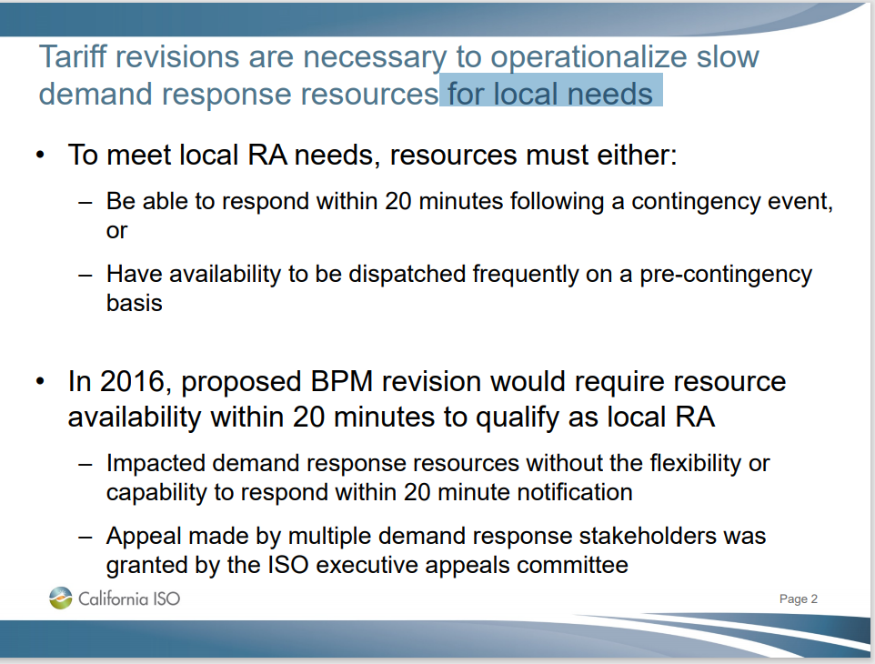
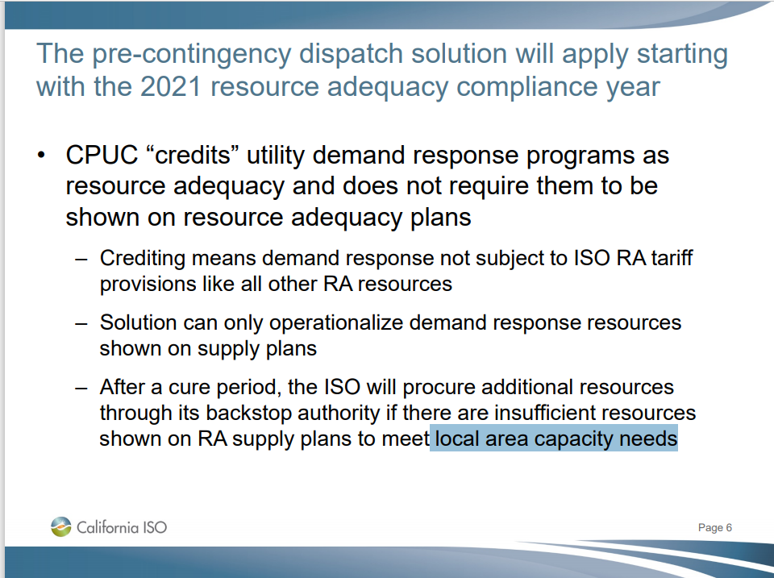

Further, in its approval, CAISO requested not permission to implement these changes through a BPM change, but through tariff revisions, as shown in the figure below (emphasis added):
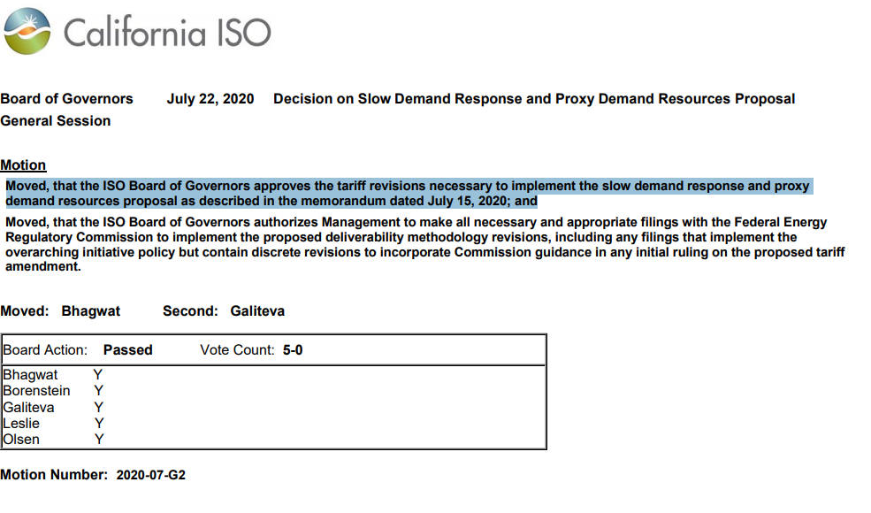
Finally, even if it was authorized by the Board, which we do not believe occurred, it cannot be implemented through a BPM change because it is not a ministerial matter and will have a material impact on rates, as discussed previously.
- CAISO’s Proposed Change Is Inconsistent with State Law and State Policy
Finally, CAISO’s proposal to not allow any Demand Response resources to count for system resource adequacy is inconsistent with state law and state policy regarding the loading order. First, California Public Utilities Codes, Section 380 states the following:

(a) The commission, in consultation with the Independent System Operator, shall establish resource adequacy requirements for all load-serving entities.
(b) In establishing resource adequacy requirements, the commission shall ensure the reliability of electrical service in California while advancing, to the extent possible, the state’s goals for clean energy, reducing air pollution, and reducing emissions of greenhouse gases. The resource adequacy program shall achieve allof the following objectives:

* * *
(2) Establish new or maintain existing demand response products and tariffs that facilitate the economic dispatch and use of demand response that can either meet or reduce an electrical corporation’s resource adequacy requirements, as determined by the commission.

In addition, CAISO’s proposed BPM change in inconsistent with California’s adoption of the loading order, which is codified in part, California Public Utilities Code 454, which states:
- The electrical corporation shall first meet its unmet resource needs through all available energy efficiency and demand reduction resources that are cost effective, reliable, and feasible.
The state’s loading order is also discussed in the 2008 Energy Action plan and that plan indicates that it was “established that the state, in meeting its energy needs, would invest first in energy efficiency and demand-side resources, followed by renewable resources, and only then in clean conventional electricity supply.”
Further, California Public Utilities Code, Section 345.5, requires the following of the CAISO:
(a) The Independent System Operator, as a nonprofit, public benefit corporation, shall conduct its operations consistent with applicable state and federal laws and consistent with the interests of the people of the state.
(b) To ensure the reliability of electric service and the health and safety of the public, the Independent System Operator shall manage the transmission grid and related energy markets in a manner that is consistent with all of the following:
(1) Making the most efficient use of available energy resources. For purposes of this section, “available energy resources” include energy, capacity, ancillary services, and demand bid into markets administered by the Independent System Operator. “Available energy resources” do not include a schedule submitted to the Independent System Operator by an electrical corporation or a local publicly owned electric utility to meet its own customer load.
(2) Reducing, to the extent possible, overall economic cost to the state’s consumers.
(3) Applicable state law intended to protect the public’s health and the environment.
(4) Maximizing availability of existing electric generation resources necessary to meet the needs of the state’s electricity consumers.
(5) Conducting internal operations in a manner that minimizes cost impact on ratepayers to the extent practicable and consistent with the provisions of this chapter.
(6) Communicating with all balancing area authorities in California in a manner that supports electrical reliability.
(c) The Independent System Operator shall do all of the following:
(1) Consult and coordinate with appropriate state and local agencies to ensure that the Independent System Operator operates in furtherance of state law regarding consumer and environmental protection.
For the foregoing reasons CPUC Energy Division staff respectfully requests that the CAISO withdraw PRR 1280.

Available at http://www.caiso.com/Documents/DecisiononSlowDemandResponseandProxyDemandResourcesProposal-Motion-July2020.pdf
2008 Energy Action Plan, available at https://www.cpuc.ca.gov/eaps/

